Gamma function

Property

Property 1:

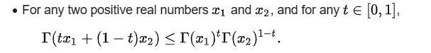

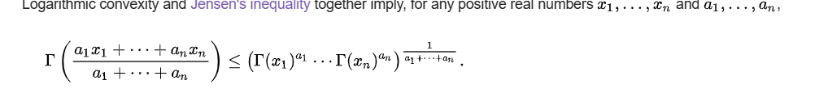

Proof:

Property 1:

Gamma function is a continuous convex function.

By Jensen’s in equality, one put $$Gamma\left(z\right)$$ as $$f$$

Hence proved.

$$\ln\left(z\right)$$ =

$$\left(1−\frac{1}{z}\right)⋅\left(r+\ln\left(2\right)\right)⋅\left(1−z\right)⋅\ln\left(pi\left(\right)\right)$$

$$−\frac{1}{2}\ln\left(\sin\left(pi\left(\right)⋅z\right)\right)+\frac{1}{pi\left(\right)}⋅sigma\left(\frac{\ln{n}}{n}⋅\sin\left(2⋅pi\left(\right)⋅n⋅z\right),n=1,n=\inf{}\right)$$

Rabbe’s formula

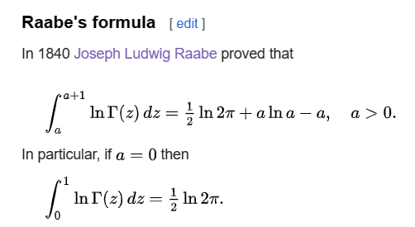

Pi function

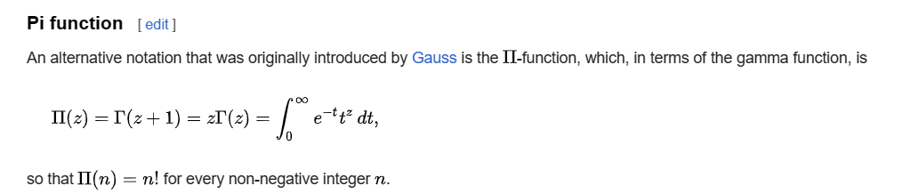

Ref